4.40: a) The force the astronaut exerts on the rope and the force that the rope exerts on the astronaut are an action-reaction pair, so the rope exerts a force of 80.0 N on the astronaut. b) The cable is under tension. c) 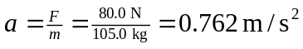. d) There is no net force on the massless rope, so the force that the shuttle exerts on the rope must be 80.0 N (this is not an action-reaction pair). Thus, the force that the rope exerts on the shuttle must be 80.0 N. e) 

